Green Or Green? | May 18  2007
 |  | Taylor Kemp




Green or Green
Taylor Kemp
A new opportunity awaits our fair city. All at once we have all this open space, but no one knows what to do with it.
First, George Lucas donated 300 acres of Presidio land which we will refer to as “L” because he realized that he did not need it all for his Letterman Digital Arts center.
Then, the navy closed its 100 acre Hunters point shipyard and then donated the unused space to the people which we will refer to as “S”.
And as if San Francisco wasn’t about to get a whole lot more open already, At&t Park’s lease ran out on the 150 acres of land they used for their parking lot which we will refer to as “P”
That makes 550 acres of land for us to soak up and stretch our legs a little more than being cramped into the city.
The problem is no one knows what to do with it. They don’t know if it should be businesses to buy goods from beautiful little corner shops, or if the people of the city deserve a nature walk through acres and acres of fresh nature. Businesses will be “B” and nature will be “N”.
The business people and nature people finally came to an accord after months of arguing, assassinations, protests, and the loss of many soldiers from both sides.
Here are the terms of their settlement:
- At most 200 acres of the navy shipyard “S” and At&t parking lot “P” could go to nature “N”.
- The amount of navy shipyard “S” for nature “N” and At&t parking lots “P” used for business “B” had to be exactly 100 acres.
- Business “B” has to have at least 300 acres of everything combined.
Also the city wants to know what combo of land will make the people happiest in a presentation at the mayor’s office, and they want to know what is the cheapest solution to the division of the land. Here is the chart the mayor’s office provided for breaking down the costs:
Type of land | $ Cost for each acre of nature “N” | $ Cost for each acre of business “B”
Lucas Presidio “L” | 50 “LN” | 500 “LB”
Navy Shipyard “S” | 200 “SN” | 2000 “SB”
At&t parking lots “P” | 100 “PN” | 1000 “PB”

The mayor’s office needs your company to solve this dilemma and present it professionally to a board of both sides.
After Late nights without sleep and 324.36 gallons of coffee, your company has come up with this set of constraints with which to work with.

Lucas presidio=L
Navy shipyard=S
At&t parking lots=P
Nature=N
Business=B

Constraints:
- LN+LB=300
- SN+SB=100
- PN+PB=150
- SN+LB=100
- SN+PN≤200
- LB+SB+PB≥300
- LN≥0
- LB≥0
- SN≥0
- SB≥0
- PN≥0
- PB≥0

To perform this feat of modern city engineering, I will take the following mathematical steps: (note: the numbering of the steps here matches the numbered steps in the work section. It is basically an outline of my work section. All new terms found in this outline are defined in the section they refer to.)
- Crash Course in constraints
- List all combinations of constraints
- Put all of the constraints in the form of identity matrices
- Multiply the identity matrices by their inverse to find the “B” matrix
- Multiply the “B” matrix that you found by the “money” matrix to find cost of land assortment

Getting started:

A Crash course in matrices: (Skip to Number 1 if you already know about matrices and how to multiply them)
First of all here are some of the terms we use for matrices. Rows are the part of a matrix that go from right to left, columns are parts of the matrix that go from top to bottom. Dimensions are the size of the matrix in number of numbers up and down called rows and columns, they are usually given in rows x columns so a matrix that is referred to as “2 x 3” will have 2 rows and three columns.
So here is what a 2 x 3 matrix looks like:
Columns
1 | 4
2 | 5
3 | 6
Rows

You are going to multiply these two matrices:
1 | 3
2 | 4
5 | 7 | 9
6 | 8 | 0

Make sure that the numbers of columns of the first match the number of rows of the second.
In this case they do 2 x 2 2 x 3
Also you can tell that this matrix will end up being 2 x 3 because of the rows of the first and columns of the second.
Here is the tricky part, now you have to multiply the spot 1, 1 on the first and 1, 1 on the second, then you have to multiply 1, 2 on the first and 2, 1 on the second. The sum of those to products will be the space 1, 1 on the resulting matrix. Then space 2, 1 on the final is a sum of the product of 2, 1 x 1, 1 +2, 2 x 1, 2. Here is a better illustration:
so you need to go 1 times 5 plus 3 times 6 to fill in the first row, first column spot of the answer matrix.

X
1 | 3
2 | 4
5 | 7 | 9
6 | 8 | 0

- Here is a crash course in constraints: Constraints are just mathematical ways to say what was said in the description of the problem, they define the outside area of the feasible region of a graph. The feasible region is the region in between all of the lines of the functions where any point within it will fit all of the constraints. You need to eliminate the constraints that will not work together and are outside the feasible region so you do not have to test all of the combinations that would happen with this many constraints.
- First you need to list all of the constraints and figure out which ones are useful. The constraints are referred to by the number they are listed as above. 1, 2, 3, and 4 must be in every set because they MUST be true in order to solve the problem within the constraints because they are the constraints that describe the amount of land that each area has, obviously you cannot physically have more or less land than is there.
Here are the combos: (1, 2, 3, 4 are implied at the beginning of the combo)

5,6-5,7-5,8-5,9-5,10-5,11-5,12-6,7-6,8-6,9-6,10-6,11-6,12-7,8-7,9-7,10-7,11-7,12-8,9-8,10-8,11-8,12-9,10-9,11-9,12-10,11-10,12-11,12

Bad Combos | Violates
7, 8 | 1
11, 12 | 3
9 | all
8, 10 | 3
1, 7 | 4
8, 12 | 3
10, 12 | 5
5, 11 | 4
Good Combos
5,6
5,8
5,10
5,12
6,8
6,10
6,11
6,12
8,11
10,11
7 and 8 violate 1 because if LN and LB are zero they cannot equal 300

11 and 12 violate 3 because if PN and PB equal zero they cannot equal 150

9 violates everything it is in because it offsets 5 and 6 if SN equals zero than PN is 200 and that can’t work because PN and PB equal 150. Truthfully I cannot find sufficient evidence either way for 9, so I addressed my piers and no one else could sufficiently prove it either way, so since I was able to find out that it violates so many constraints in many combinations for the purposes of this problem it will not be included.

8 and 10 violate 3 because if LB and SB equal zero than PB must equal 300, but it can’t because PN and PB must equal 150

1 and 7 violate 4 because if LN is zero, than LB must be 300 base on 1, but SN and LB only add to 100

8 and 12 violate 3 because if LB and PB are zero than PN must equal 150 and that means based on 5 that SN must equal 50 and based on 4 that means LB must equal 50 but it is already equal to zero

10 and 12 because if SB equals zero than based on number 2 SN must equal 100, and if PB equals zero than based on number 3 PN must equal 150 but number 5 is violated because SN and PN must equal 200

5 and 11 violate 4 because if PN equals zero than based on 5 SN must equal 200, but in 4 SN and LB only add to 100

- Then you must put all of these combinations in matrix form: For this I saved time by making the first matrix of 1, 2, 3, 4 and then all of the other combinations in their own matrices, I will put them together to multiply them. The matrices on the side are the “B” answer matrices, the big ones are the “A” coefficient matrices, and you are solving for the “X” variable column matrix. You have to look at each constraint and see what combinations it addresses to find out how to fill in the matrix. So for example constraint 1 (LN+LB=300) addresses LN and LB so there will be a 1 in the columns for LN and LB and a zero in all of the others as you can see below.

 | LN | LB | SN | SB | PN | PB
1 | 1 | 1 | 0 | 0 | 0 | 0 |  | 300
2 | 0 | 0 | 1 | 1 | 0 | 0 |  | 100
3 | 0 | 0 | 0 | 0 | 1 | 1 |  | 150
4 | 0 | 1 | 1 | 0 | 0 | 0 |  | 100
5 | 0 | 0 | 1 | 0 | 1 | 0 |  | 200
6 | 0 | 1 | 0 | 1 | 0 | 1 |  | 300
5 | 0 | 0 | 1 | 0 | 1 | 0 |  | 200
8 | 0 | 1 | 0 | 0 | 0 | 0 |  | 0
5 | 0 | 0 | 1 | 0 | 1 | 0 |  | 200
10 | 0 | 0 | 0 | 1 | 0 | 0 |  | 0
5 | 0 | 0 | 1 | 0 | 1 | 0 |  | 200
12 | 0 | 0 | 0 | 0 | 0 | 1 |  | 0
6 | 0 | 1 | 0 | 1 | 0 | 1 |  | 300
8 | 0 | 1 | 0 | 0 | 0 | 0 |  | 0
6 | 0 | 1 | 0 | 1 | 0 | 1 |  | 300
10 | 0 | 0 | 0 | 1 | 0 | 0 |  | 0
6 | 0 | 1 | 0 | 1 | 0 | 1 |  | 300
11 | 0 | 0 | 0 | 0 | 1 | 0 |  | 0
6 | 0 | 1 | 0 | 1 | 0 | 1 |  | 300
12 | 0 | 0 | 0 | 0 | 0 | 1 |  | 0
8 | 1 | 0 | 0 | 0 | 0 | 0 |  | 0
11 | 0 | 0 | 0 | 0 | 1 | 0 |  | 0
10 | 0 | 0 | 0 | 1 | 0 | 0 |  | 0
11 | 0 | 0 | 0 | 0 | 1 | 0 |  | 0

- Then you program these matrices in to the calculator by pressing 2nd>Matrix then going over to edit and pressing enter on A and putting in 6x6 for the dimensions, then you have to scroll over to each number and program each one in for the coefficient “A” matrices. Then you press 2nd>Quit and go back to matrix and go to b and press it and then put 6x1 for the dimensions of this matrix and put in the answer “B” matrix for each one. Once you have programmed in the matrix, you need to press 2nd>Matrix and highlight A and press Enter, then press the x⁻¹ (invert) button then get back to the matrix screen, then press B and press Enter. You have to press the invert button to get the inverse matrix of A before you can multiply it by b, you are essentially taking the identity matrix (the matrix that identifies which ones are included ) and inverting them to find the real coefficient matrices which include how much of each there are. You will need to repeat this process for each combination’s matrices, you can clear the calculator between each one by pressing 2nd>+>7>1>2 Then The resulting matrices are:

5, 6 | 50 | 5, 10 | 300 | 6, 8 | 300 | 6, 11 | 225 | 8, 11 | 300
 | 250 |  | 0 |  | 0 |  | 75 |  | 0
 | -150 |  | 100 |  | 100 |  | 25 |  | 100
 | 250 |  | 0 |  | 0 |  | 75 |  | 0
 | 350 |  | 100 |  | -150 |  | 0 |  | 0
 | -200 |  | 50 |  | 300 |  | 150 |  | 150
5, 8 | 300 | 5, 12 | 250 | 6, 10 | 300 | 6, 12 | 150 | 10, 11 | 300
 | 0 |  | 50 |  | 0 |  | 150 |  | 0
 | 100 |  | 50 |  | 100 |  | -50 |  | 100
 | 0 |  | 50 |  | 0 |  | 150 |  | 0
 | 100 |  | 150 |  | -150 |  | 150 |  | 0
 | 50 |  | 0 |  | 300 |  | 0 |  | 150
5, 6 – 6, 8 – 6, 10 – and 6, 12 do not work because you cannot have any negative land
8, 11 and 10,11 violate constraint 6 because LB SB and PB are not more than 300
6, 11 is the only one that fulfills all of the constraints so it will be the one I will calculate the price for because it must be the minimum.
- Now I will translate the 6, 11 combination “X” matrix numbers and the price data into matrices to be multiplied together. The money matrix is derived from the chart that describes how much each acre of land will cost from above.
 |  | Acres
6, 11 | LN | 225
 | LB | 75
 | SN | 25 |  | LN | LB | SN | SB | PN | PB
 | SB | 75 | Money | 50 | 500 | 200 | 2000 | 100 | 1000
 | PN | 0
 | PB | 150

When you multiply the 1x6 “money” matrix by the 6x1 “6, 11” matrix you get a 1x1 matrix of:
[353,750]

I checked the problem by multiplying each amount of acres by the amount it costs

Finally:

In English this all means that if you :
Give 225 acres of Lucas presidio to nature at a cost of 50$ per acre
75 acres of Lucas presidio to business at a cost of 500$ per acre
25 acres of Navy shipyard to nature at a cost of 200$ per acre
75 acres of Navy shipyard to business at a cost of 2,000$ per acre
0 acres of At&t parking lots to nature at a cost of 100$ per acre
And 150 At&t parking lots to business at a cost of 1,000$ per acre

Total you have just spent $353,750.00 developing the land given to the city for everyone to enjoy in the most cost effective means possible.

This answer is the only one that has to be a corner of the feasible region because it is the only one that works, and also since it is the only one of our ten that works, it must be the minimum cost corner of the feasible region which if we had taken that route to solve the problem would have been a 6 dimensional graph!! That is why we use matrices to solve the problem instead of a graph. We used 6x6 matrices because we had 6 constraints by 6 variables.

Here is what I think is the best way to allocate the land:
The Land in question:
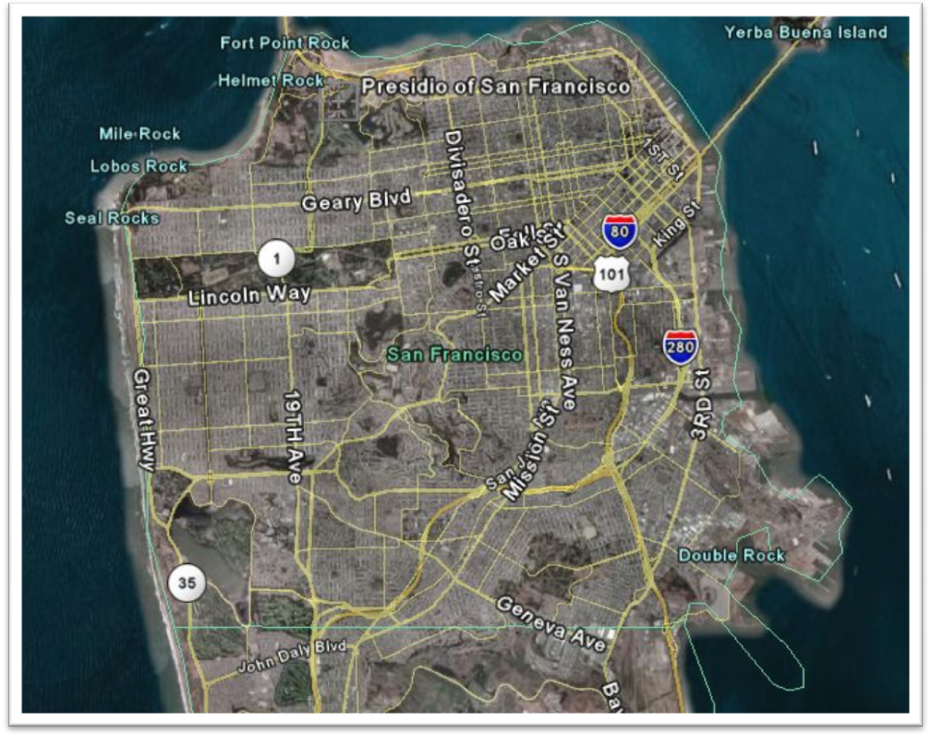
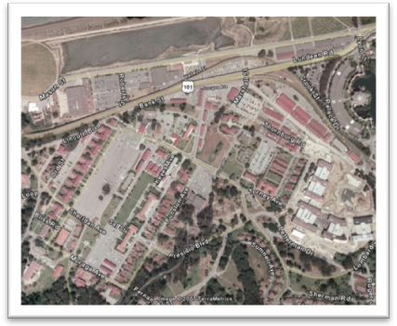
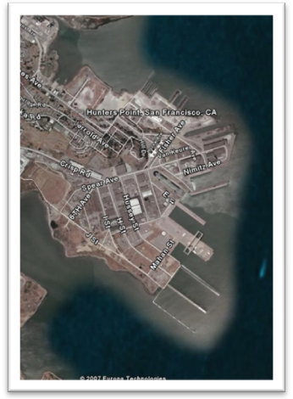
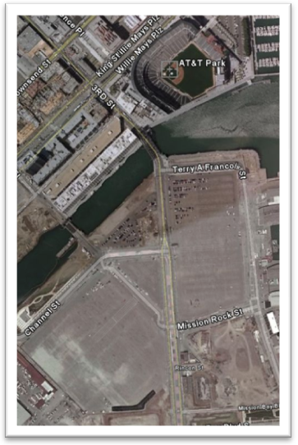
Lucas Presidio
At&t Parking Lots
Hunters Point

I could not find another answer to all of the constraints besides the one I found for the answer to the problem, but regardless of the agreements that each side came up with, this is the way I think the land should be divided:
Hunters point shipyard was a Naval shipyard located on 638 acres of waterfront on the southeast corner of the city. The original docks, built in 1916 on solid rock, were the largest dry docks in the world at the time. At over 1000 feet long, they were known to be the only docks that could easily accommodate the largest war vessels, cargo ships, and steamers afloat at the time. There was an off shore depth of 65 feet which made Hunters point the ideal dock for any size ship the human race could conjure up. The Navy used the docks as a mid stop between San Diego and Bremerton, Washington. In the early 20th century, the land was extended further into San Francisco bay by landfill. The Navy acquired exclusive use of the docks from just before WWI to 1974 when it was leased to a commercial ship repair company. All the industry of the area led way for the creation of many industrial jobs and created a new reason for many more people to move to the city. Because of all of this industry, the Hunters point shipyard is one of the most toxic areas of land on the west coast, since 1994 the land has mostly been unused and paid no attention to except by the federal government to clean up all of the toxic waste that still plagues the area today. I think that Hunters point should be completely devoted to business for a number of reasons. First of all, it would be a miracle if the area were even able to be cleaned up enough to grow any nature and have it be safe. Second of all it is a prime location for docking of commercial vessels such as tour boats and cruise ships which would make it a perfect place for business centers and nice places to shop that visitors of San Francisco on tours and cruise ships could enjoy. Making it a business center would be great and turn land that had previously been neglected into a vibrant flourishing center for shopping and tourism. The only downside to this plan is that Hunters point businesses are the costliest type of allocation you can have there at 2000$ per acre, but I believe it will be well worth it.
At&t Park has been the home of the Giants since 2000. In its short life span it has been called SBC park and Pacific bell park before being named At&t park in 2006. The Parking lots at At&t park need to be handled with care. The inner part of the parking lots is built on solid land, but the outer parts are built on landfill, like much of that edge of the city. The parking lots at At&t park had formerly been a shipyard just like Hunters point. I think the best way to divide the Land is to have the inner 50 acres for nature and the outer 100 for business. The inner 50 acres must go to nature because there is too little nature in that part of the city, the closest thing to be considered nature is over 2 miles away, and it is unfair for the people that live near there to not have any green space to get away to. Also any nature would have a gorgeous view of the bay right there!The other 100 acres is for business because that land is landfill and would be hard to grow anything on. It would be great to have businesses so close to at&t Park. Just think, if there were a whole bunch of restaurants souvenir shops and other tourist and Giants fan goodies in that area. Picture this, you have just been in a Giants game for 3 hours, you are hot and your skin still aches from getting out of that chair you were stuck to. You have been to that area a thousand times for many games, and you know that any local stores, which are few and far between, are overrun with people just like you wanting a cool place to unwind from the game. You ache at the thought of having to wait hours to get a muni, Taxi, or having to walk miles down town to get the refreshment you deserve. But then you see that there are 100 acres of new stores right there! They are the prettiest little stores ever with brand new buildings and great views of the bay right off the water, and suddenly you are having a blast after the game!!!
The presidio of San Francisco is now a national landmark/park on the Northern tip of San Francisco. For centuries it was a fort founded in 1776 by Spanish settlers. It was originally named El Presidio Real de San Francisco. The presidio saw heavy use as a fort during any conflict the U.S. had in the Pacific over the last century including WWII, Korea, and Vietnam. It was given to the national park service in 1994 and since then has undergone extensive renovation to keep the historic buildings looking new and to preserve the area’s history. It is the only national park that is heavily residential. It will be fully renovated and developed and self sufficient by 2011. The Letterman digital arts center was constructed on the original site of the Letterman hospital which had seen years of use as an army hospital and had cared for hundreds of thousands of soldiers. I think that 250 of the 300 acres of land given to the city by Lucas needs to be nature. The presidio already has so many historic buildings and things like that that it has almost created a bubble locking out the vibrant nature all around the area. I think that nature needs to be let in and given room to breathe. That area of the city is the number 1 recreational area of the city. It has Crissy field (a remodeled air force base), It borders the Golden Gate bridge and the marina and the beach, and is just blocks away from Golden Gate park. It would be amazing to be able to drive for 10 minutes from almost anywhere in the city and have a huge recreational nature area to get to. It would not only benefit the immediate area, it would benefit the whole city by making it a beautifully diverse city with a perfect balance of nature and business. Also the Presidio nature is the cheapest type of land on the list to develop at only 50$ an acre. I did throw in 50 acres of business just to have a little slice of civilization in the area in case you get tired of all the nature around the area once it is developed the way I said it should be.
To recap:
I gave:
All 100 acres of Hunters point to business
100 acres of At&t parking lots to business and 50 acres to nature
250 acres of Lucas Presidio to nature and 50 acres to business

In a matrix that looks like:
 | Acres
LN | 250
LB | 50
SN | 0
SB | 100
PN | 50
PB | 100
Again I multiplied this matrix by the cost matrix shown in step 5 above.
The total amount to develop the land in the way I said is: $342,500
Not only will the city optimize its land with my plan, but by going back on the compromises made by the two parties the city will save $14,250! What a bargain!
Reflection:
Note to Newsom: Changes can happen to the scheme. If any of the parties decide to take back some land or give more land, the whole problem must be reworked at least from step 2, possibly the whole thing from the beginning. Another change is if the parties just decide to rethink the amount of land they want. Either way I hope you will choose Taylor Made City Planning for all of your green(plants) or green(money) allocation needs.
At the beginning of this problem I was lost. I did not know where to go after the part where I laid out all of what I knew about the problem. Initially I knew it would be something to do with identity matrices, but I did not know how I would translate it into them. My peers were by far the biggest source of help on this problem. I would not have gotten nearly this far without them. I felt that my group worked very well together, we all did our own work, but we verified it by checking each other’s.
My initial plan was to put nature and business on one side of the matrix and then L, P, and S on the top and put 1 where there was an instance of that variable in each constraint and 0 if not. This plan was close, but it would have failed because when I would have multiplied them they would have been conflicting dimensions. Once again my group saved my butt and we figured out how to do it. From there it was easy sailing as I had kind of figured out what to do for the rest; however, when I got to the part where you have the x matrix after you have multiplied the coefficient matrix, I kind of did not know what it meant, then someone told me to put all of the variables on the side of the 6x1 matrix and then translate the money per acre chart into a 1x6 matrix and multiply those together.
Some changes that would affect my answer would be if I messed up on just 1 spot on copying, multiplying, or translating any of the matrices it would end in disaster and would register all of my answers null and void. But that is a scary thought, and since it is too late in the game to think about that, let’s turns to a happier note. If I messed up on translating the money matrix it would probably result in less money being spent.
The math that was used in this project is useful for various other things. It is useful in solving a problem where you have to maximize or minimize something without having to make a multi dimensional feasible region. It is also useful in pin pointing the exact amount of a certain number of things that you need to fill not only the normal constraints, but the type of constraints like the ones that described the agreement made between the nature and business party. It can get directly to the right answer by elimination much faster than any other method I know to do that.
For My presentation, I will make an interactive PowerPoint. My PowerPoint will be a very easy to use step by step guide with helpful animations of exactly what you should do to solve the problem so my assigned algebra II level mathematician can do the problem.

