Introduction
Company Profile: Jets R’ Us is located in beautiful San Francisco, California. We’ve been serving the country with a steady supply of water jets for the last 25 years. Jets R’ Us is a family owned store that has been owned by Tellez after Tellez. We’re the largest manufacturer and designer of water jets and we’re always trying to think outside the box. Our jets are manufactured here in the United States ensuring the quality of each and every jet will be long lasting and in perfect working condition. We offer three types of jets. Each jet has a range for how high it can shoot our water. The three different types of jets are mini jets, jets, and super jets. Mini Jets shoot water out 10-30 ft., jets shoot water out 50-100 ft., and super jets shoot water out at 250 ft.

Bellagio Request: The Bellagio IRC has proposed a contract for Jets R’ Us. Their business has been dropping as of late because people have grown bored of their main attraction, which are their fountain shows. They have proposed that Jets R’ Us design and build a new fountain show for the prestigious hotel. We will need at least 3 different heights of jets and a minimum of 10 nozzles. We also know that the pool is 8 acres large which is 340,000 square feet. The Dimensions are 1000 ft. long, 340 ft. wide, and 10 ft. deep. The hotel has requested that the guests not be wet, so the water should not land outside the lake area. The hotel has also requested for the water to cover 55% of the pool should be used if not more. The equation for the biggest jet in the pool is h(d)=-0.014x^2+14x-3263.4. This super jet should be in the middle of the pool.

Mathematical Preface: Parabolas will dominate the math that will be required here. I will need to graph quadratics based on their equations, figure out their roots, vertex, and how to graph quadratics. Depending on the size of the jet and how far it is being shot we will be able to determine the area that the jet is taking up along with the distance the water will cover. To make sure that 55% of the area is at least covered we will need to find the total area of each circle with A=$pr\hat{2}$. After divide the total area that I got from the circles which is 219,910.6 by the area of the pool, which is 340,000. That gives me 0.65. that multiplied by 100 gives me 65% of the pool is being covered, so that meets the constraint.

Design Visual
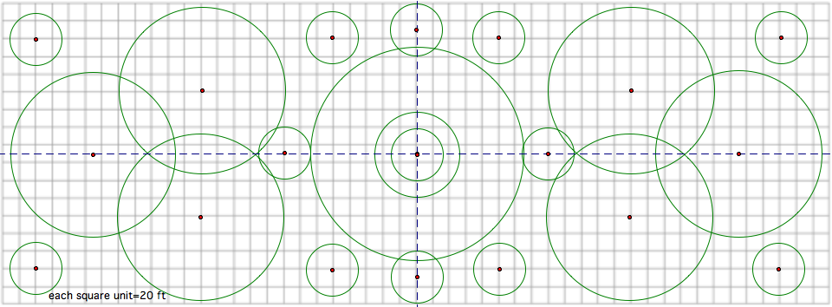
The math that was used in the bird’s eye view revolved around parabolas because of the shapes that the water formed. The water was shot up into the air by the force of the jet, but once it reaches its vertex or highest point it can go with the given force, gravity takes over and brings the water back to the ground. This process gave the water the unique shape of a parabola. After establishing what shape the water would form I needed to find roots, vertexes, and put the equations into vertex and standard forms. I needed the roots because they tell me where the parabola or curve of the water coming out of the jet starts and ends. The start of the water shooting out is represented in a coordinate graph by (0,0) The Vertex is the highest point where the water will reach, and standard equation is the final form where it shows how to graph the parabola. For example to find the roots of a curve I needed know the radius of the circle and because the radius is half a circle. The water shoots from the middle of a circle so from the middle to the edge of the circle that would give me the roots. This is the same process that I used to find the roots of the middle jet. According to the constraints the middle jet was the biggest jet in the entire pool so to find the roots I needed use the same process as stated above. The equation that for the biggest jet was h(d)=-0.014x²+14x-3263.4. Since that was the equation of the main or biggest jet we just used the quadratic formula and filled in the A’s B’c and C’s. The A variable was -.014, the B variable was 14, and C was -3263.4. These were what the variables in the quadratic formula stood for.
$$\begin{aligned}x\text{=-}\text{.}\text{014}x\hat{2}+\text{14}x−3,\text{263}\text{.}4 \\ A\text{=-}\text{.}\text{014} \\ B=\text{14} \\ C\text{=-}3,\text{263}\text{.}4 \\ x=\frac{−b(+−)\sqrt{b\hat{2}−4\text{ac}}}{2\text{ac}} \\ x\text{=-}\text{14}(+−)\frac{\sqrt{(\text{14})\hat{2}−4(−\text{.}\text{014})(−\text{3263}\text{.}4)}}{(2)(\text{.}\text{014})} \\ x\text{=-}\text{14}(+−)\frac{\sqrt{\text{196}−\text{182}\text{.}\text{78}}}{−\text{.}\text{028}} \\ x=\text{630},x=\text{370}\end{aligned}$$

After filling in the numbers for the variables in the quadratic formula it gave the two answers of 630 and 370. Those 2 were the roots for the biggest jet.
Even though finding the roots and doing the jet analysis was the difficult part of the project designing the actual project was just as hard. The reason it was still really hard was because of the constraints the hotel had put on my company. The jet fountains had to cover over 55% of the total area and although it was a lot of fun to just draw circles and make them look nice, I had to keep these constraints in the back of my mind. The way I worked around these constraints were by trying to make my design as symmetrical as possible. Although this was a constraint that the hotel was putting on my company, I used it to my advantage. By having to put the exact circle on each corner of the pool that caused more area to be used. One of the constraints from the hotel was the pool had to be symmetrical four ways. That means if I were to break the pool into quadrant graph with four quadrants if I put a circle in one quadrant I’d have to do the same size circle in the same place in the other three quadrants. So I used this in the way I designed the fountain and not only did that make the pool area look better but it also filled up a lot more area which eventually helped me reach the 55% area mark.
Total Area of Circles = 219,910.6ft.
Area of the Pool = 340,000ft.
219,910.6 / 340,000 = 0.647
0.647x100 = 64.7% of Area covered

Once the design was done and I thought that more than 55% of the area was being covered I had to add up the entire areas of each circle. I knew that the area of the pool was 340,000 square feet so then the next step was using the formula to find area of each circle. I used A=(π)r^2 to find the area of a circle. I found out what the radius was for each circle by counting the squares across each circle. Each unit squared was equal to 20ft. squared. The radius is half of the diameter of a circle so after that I just cut the diameter in half and that gave me the length of my radius. Once I repeated this step for each circle I added the areas of each circle together and it came out to be 201,376.04 square feet. 340,000 by the number I got and it was obvious that the result was over 55% of the total area of the pool.
$$\begin{aligned}\text{Circles}(1\text{&\#}\text{11}−\text{22})\end{aligned}A=p\left(r\right)\hat{2}A=p(\text{30})\hat{2}A=2,\text{827}\text{.}\text{43}\text{ft}\text{.}2,\text{827}\text{.}\text{43}x\text{13}=\text{36},\text{756}\text{.}\text{59}\text{ft}\text{.}\text{Circle}(2−4\text{\&\#}7−9)A=p\left(r\right)\hat{2}A=p(\text{100})\hat{2}A=\text{31},\text{415}\text{.}\text{92}\text{ft}\text{.}\text{31},\text{415}\text{.}\text{92}x6=\text{188},\text{495}\text{.}\text{52}\text{ft}\text{.}\text{Circle}(5)A=p\left(r\right)\hat{2}A=p(\text{50})\hat{2}A=7,\text{853}\text{.}\text{98}\text{ft}\text{.}\text{Circle}(6)A=p\left(r\right)\hat{2}A=p\left(\text{70}\right)\hat{2}A=\text{15},\text{393}\text{.}\text{80}\text{ft}\text{219},\text{910}\text{.}6/{\text{340}},\text{000}=0\text{.}\text{647}0\text{.}\text{647}(\text{100})=\text{64}\text{.}7\text{\%}$$
For the total area of all 13 circles
For the total area of all 6 circles
Area of Circles Divided by Total Pool Area

Mathematical Rationale:
The paths of the streams of water were obvious because of the way gravity reacts on everything. Since the water was being shot up I knew that it would also want to come back down to the ground. The shape that was a result of that was a parabola. So since I knew the shape that the streams of water were going to make I could apply mathematical principles to the parabolas, such as vertexes and roots. I set up a cordinate graph and made the start of the stream equal to (0,0) and the end of the stream equal to the end of the radius. For example if the radius of a circle were 30 then the start of the parabola would be (0,0) and the end of it would be (30,0). The type of jet that was being used determined the heights of the streams. For example if that very circle with the radius of 30 was a small jet then the maximum height that could be reached by that jet was only 30 ft in the air. The same process was done with other types of jets. I did the same thing for every jet as it is shown in my calculations. By doing these steps I determine the length and height of every stream.
The vertex and roots were the most important facts when it came to trying to figure out the shape and height of the streams. The vertex not only told me where the middle of the stream was but it also showed me the highest point that the water would reach before gravity took over and brought the water back to earth. For example on graph number one the vertex was (15,30). That tells me that the highest point of that jet was 30ft. tall as well as telling me that the total legnth of the water shot was 30ft. Although the vertex is 15ft. as the x that is because the vertex is half of the total distance. So 30/2=15. The roots just as the vertex told me about the shape of the stream. Unlike the vertex the roots tell me the width of stream. The roots tell me where the stream starts and where the stream will end. The roots also helped me find the vertex. What that means is the vertex will always be right in the middle of both roots. So if the roots for an parabola were (0,0) and (50,0) then we know that at least the X value of the vertex will be (25,Y) That is exactly how the roots and vertex relate to the shape of the stream and the picture of the fountain.
The design I had made for the hotel meets all the constraints. The Tallest jet meets the equation that the hotel manager has given us. My company has used all 3 different types of jets from the smallest to the biggest jet. Not only did my company meet the minimum of 10 jets used but we surpassed it. There are a total of 22 jets that are being used in my design. Not only are the jets designed in a very nice pattern that is easy for the eye to see but also none of the water goes outside of the pool area. We followed the rule that none of the water should splash the guests. Finally the amount of jets I have also shoot out enough water that over 55% of the total area is being used, so none of the of the water is going to waste. Since there is so much activity going on the crowd will be very happy and the water can be seen from any angle.

Jets #1 and #11-22 (Mini Jets 30ft.)

$\begin{aligned}k=\text{30},h=\text{15} \\ y=k(+−)a(x−h)\hat{2} \\ y=\text{30}(+−)a(x−\text{15})\hat{2} \\ 0=\text{30}(+−)a(0−\text{15})\hat{2} \\ −\text{30}=a(\text{225}) \\ −\text{.}\text{133}=a \\ y=\text{30}−\text{.}\text{133}(x−\text{15})\hat{2}\end{aligned}$

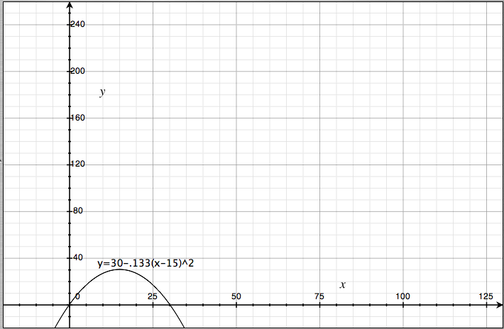

Jets #2-3 and #8-9 (Jets 75ft.)

$$\begin{aligned}k=\text{75},h=\text{50} \\ y=k(+−)a(x−h)\hat{2} \\ y=\text{75}(+−)a(x−\text{50})\hat{2} \\ 0=\text{75}(+−)a(0−\text{50})\hat{2} \\ −\text{75}=a\text{2500} \\ −\text{.}\text{03}=a \\ y=\text{75}−\text{.}\text{03}(x−\text{50})\hat{2}\end{aligned}$$
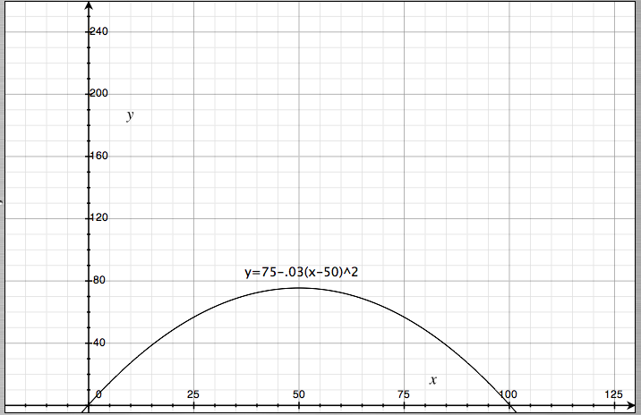

Jets #4 and #7 (Jets 150ft.)

$$\begin{aligned}k=\text{150},h=\text{50} \\ y=k(+−)a(x−h)\hat{2} \\ y=\text{150}(+−)a(x−\text{50})\hat{2} \\ −\text{150}=a(\text{2500}) \\ −\text{.}\text{06}=a \\ y=\text{150}−\text{.}\text{06}(x−\text{50})\hat{2}\end{aligned}$$
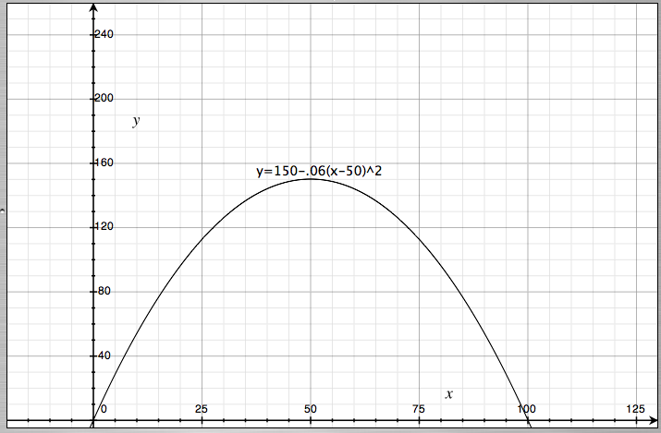

Jet #6 (Super Jet 250ft.)

$$\begin{aligned}k=\text{250},h=\text{10} \\ y=k(+−)a(x−h)\hat{2} \\ y=\text{250}(+−)a(x−\text{10})\hat{2} \\ −\text{250}=a\text{100} \\ −2\text{.}5=a \\ y=\text{250}−2\text{.}5(x−\text{10})\hat{2}\end{aligned}$$
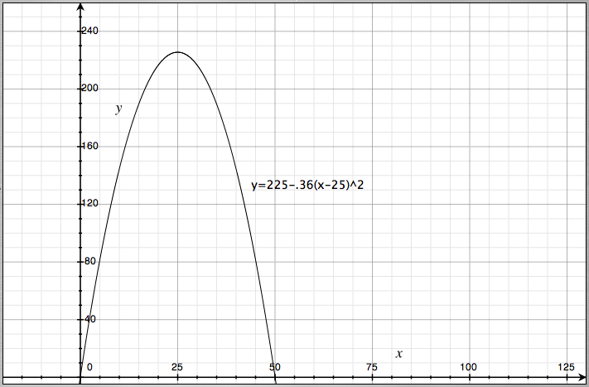
Jet #5 (Super Jet 225ft.)

$$\begin{aligned}k=\text{225},h=\text{25} \\ y=k(+−)a(x−h)\hat{2} \\ y=\text{225}(+−)a(x−\text{25})\hat{2} \\ −\text{225}=a(−\text{25})\hat{2} \\ −\text{225}=a\text{625} \\ −\text{.}\text{36}=a \\ y=\text{225}−\text{.}\text{36}(x−\text{25})\hat{2}\end{aligned}$$

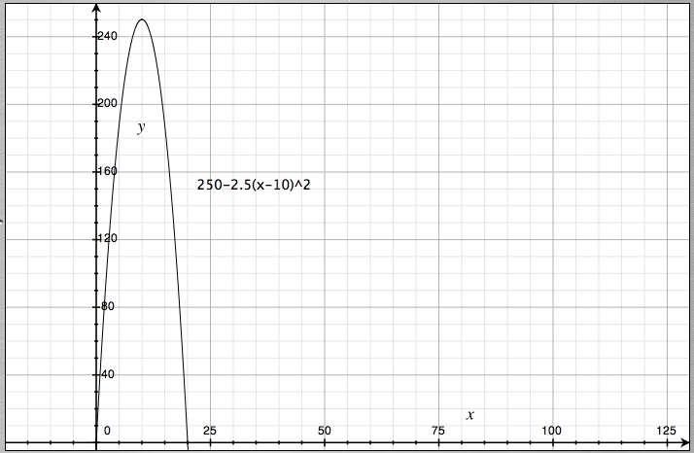

Conclusion:
Parabolas and formulas dominated the math that has dominated this job. This same type of math can be seen in many other types of real life jobs. Architecture and anything with building is the biggest example I can think of. For example if an architect is designing and building a building that has arches in it, the architect would have to calculate the slope and climb of an arch. Some other jobs that would require parabolas are any jobs that have to do with anything coming up and down. Jobs such as a roller coaster designer, suspension bridge architect and a person dealing with projectiles would all be jobs that would require knowledge with parabolas. The designer would have to calculate the ups and downs of a cart on the tracks and make sure the slope isn’t too steep or the car wouldn't be able to go up all the way. The designer would also have to calculate that there wouldn't be a parabola that was too low because if the car is going too fast it could fly off. It is true that this would also take some physics but parabolas and math also has a big part in this. For Bridges the architect would have to make sure the parabolas wouldn’t be too steep or too low or the bridge might not hold up. A projectile maker would have to calculate the force that the projectile would be shot out so the parabola he desired would be long enough to hit the targets.
Although we learned parabolas this year the math that has accumulated throughout the years is very present there. From knowing how to isolate a variable being able to square root a number. The math that I learned in first grade such as addition to the math we learned this year regarding graphing the parabolas. We learned what vertexes, roots, and what parabolas was this year and those were the first baby steps that were required to be able to do this project. Finally graphing has had a big part in this whole process as well. I remember being able to graph points on a graph and now we’re doing curves and circles.
Although I’m pretty sure my calculations are right for the most part, human error is the biggest contributor to possible errors. For example rounding numbers may not have such a big difference at the start but if the rounding continues to go on answer after answer slowly but surely the answers may become bigger or smaller. Another contributor of human error can be the builders building the fountain. The builders could have the accurate calculations that I have given them but in the process of building the fountain there are many things that they can do to make the fountain malfunction. Wind is another really big factor. Although I calculate that the water were to shoot 100 ft across the pool if the wind is too strong it could easily over shoot that.

